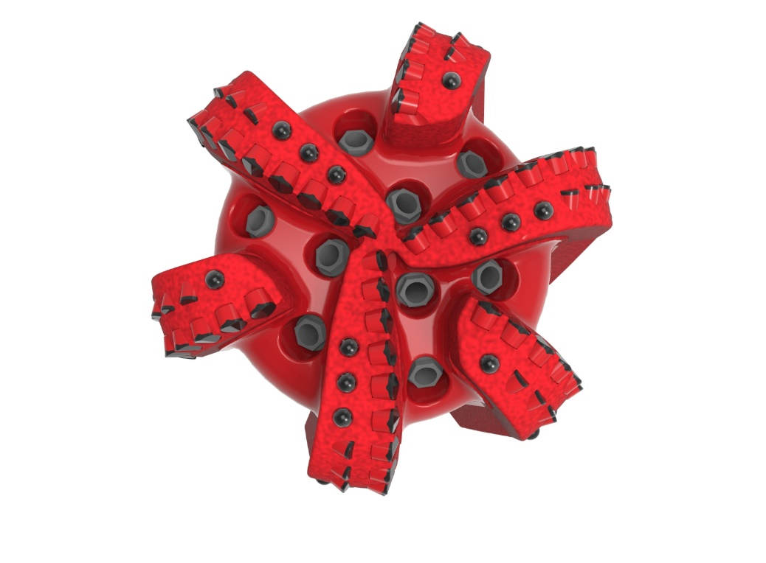
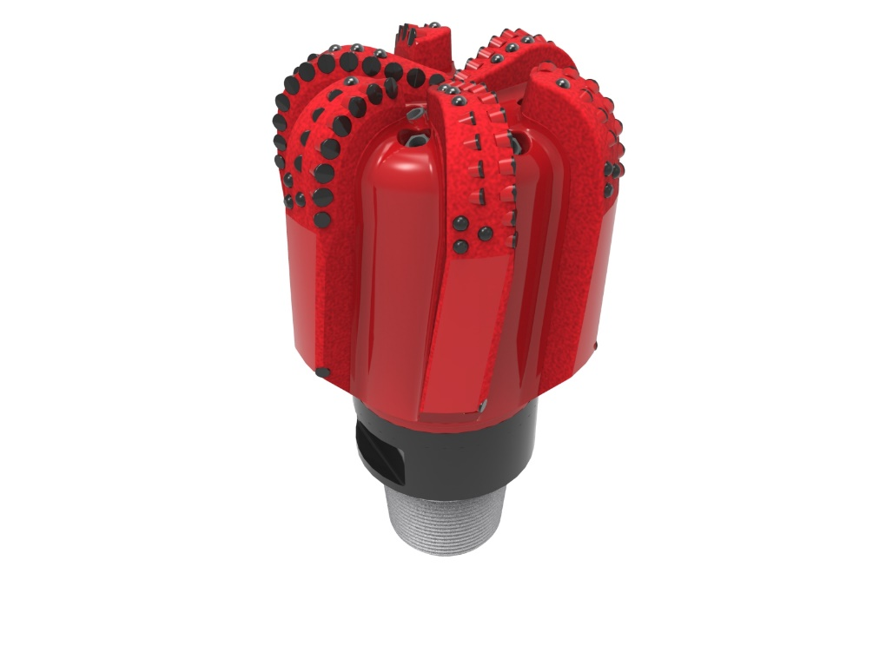

Drill Bit Specifications:
Cutter Size (Primary, Sec) | 5/8”,1/2”
Cutter Count (Total, Gage, Back Ream) | 80, 6, 6
Blade Count | 6
Gage Length (Inches) | 6.00
Nozzle Count (Primary, Sec.) | 9
Nozzle Series (Primary, Sec.) | 60
JSA (Sq. Inches) | 33.84
Max. TFA (Sq. Inches) | 3.34
Operating Parameters:
Max. Weight on Bit (1,000 Lbs.) | 60
Make-up Torque (ft/lbs) | 40,563
Nominal Dimensions:
Overall Length (Inches) | *21.66
Make Up Length (Inches) | *16.79
Bit Breaker | SKB-21011
Connection | Ø6-5/8" API Reg.
Approx. Weight (Lbs.)  *Long tool joint available upon request (adds 6” to fishing neck, makeup and overall length, and 64 lbs. to approximate weight). | *290

Taylor-Made Features:

- Premium grade cutters maximize ROP and Life
- Selectively positioned bullets for smooth drilling
- Nozzle configuration and large open face volume optimize blade cleaning and cuttings removal

616-XR9(K)(BR) Nomenclature Explained:

• | 6 | = | Number of Blades
• | 16 | = | Primary Cutter Size (16mm)
• | XR | = | Backup Cutters
• | 9 | = | Number of Nozzles
• | K | = | Bullets
• | BR | = | Back Reaming Cutters


